Here is a programming problem we ask you to read then create an iOS app to solve it. For the solution, we request that you use Native iOS UI Elements. You can use downloaded images where ever necessary.

By this assessment, we assess your -

1. Design aspect of your solution and OOP Skills.
2. Use of Most of the UI elements.
3. Using Native as well Third party APIs with use of Map and Location.
4. Server Communication with GCD skills.
5. UIView Animations skills.

Scenario (MOCK GIVEN BELOW):

- Design Tabbed View for iPhone for three tabs.

**Tab 1:** It will have a Table view with Navigation Controller, TableView with Delegates and Custom Cells -

* Custom cell one with Disclosure Indicator selecting cell will push to the collection view to show 30 cells with images from URL with lazy loading.
* Custom cell two with Disclosure Info button on which tapped will modally present a user details view.
* Custom cell three with bulb images and UISwitch for ON state bulb will ON n vice versa.
* Custom cell four with Calendar icon and non editable text field and tap on calendar should show date picker and selecting a date should be shown in the cells Textfield.
* Custom cell five with static image, title and sub title.

**Tab 2:** It should show a map view with current location annotation and using CLPlacemark & GeoCoder show info details on annotation tap.

**Tab 3:** It will have a Textview which will detect emails, addresses, phone numbers and links. It will also contain a Scrollview which scrolls horizontally to show three images with a UIPageControl.

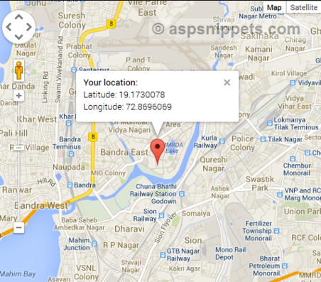

**Tab 3**

Tab 2

Tab 1

Tab 3

Tab 1

**Tab 2**

**Tab 1**

**Tab 1**

Main View

List

<

<

***i***

Bulb Image ON/OFF

Modal View

Push View

Date Input View

Title

SubTitle

Map View

Text View & Scroll View

Tab 2

Tab 3

Tab 2

Tab 3

UITextView

**. . .**

<

<

UIScrollView with UIPageControl